DDNS config
1.Register:
Step 1: visit the website http://www.dynDNS.com/ first, find "Create Account",click it and get into register interface.
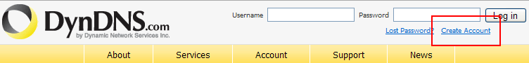

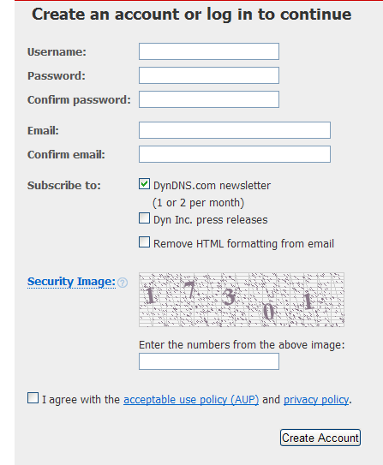
Step 2:Input the username and other information to register a account. A example is as follows:
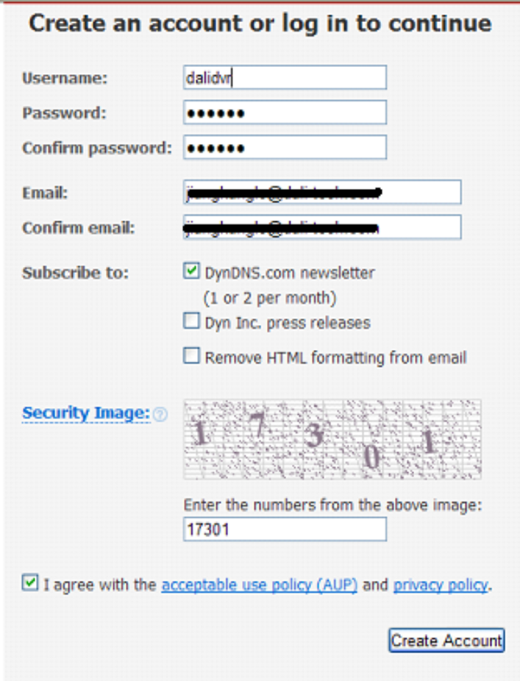

Click the "Create Account" , then the system will information like:One more step to go…

Step 3:Then open your email for register, you will find a email from DynDNS.com Support,open it then click the link in the email,then you can see "Account Confirmed".at this time, you can use the account.
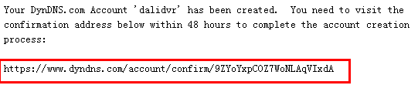
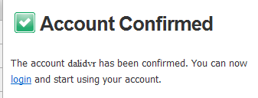

2.Host application:
Step1: visit the website http://www.dynDNS.com/ first and login by your account.

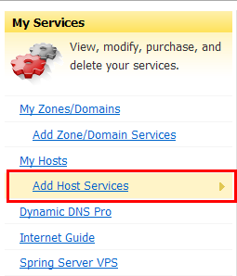
Step 2: After you have login, choose "Add Host Services"
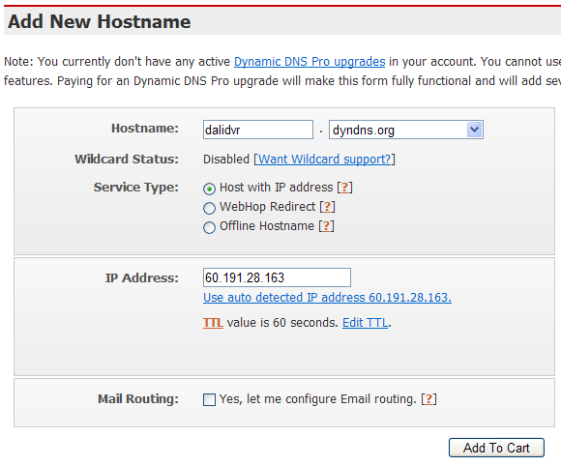
Step 3: The Hostname is the domain name. Choose "Host with IP address" in "Service Type", then input the DVR's remote IP in "IP Address".
Mail Routing is not necessary to select. Then click "Add to Cart", and click "next" in the next page, then click "Activate Services" to activate the domain name.
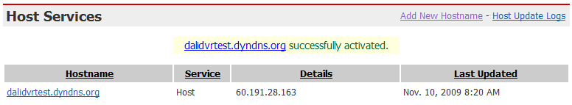

3. DDNS setup on DVR end:
Step 1:
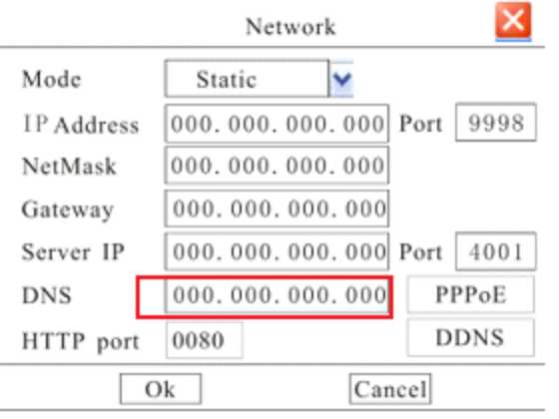
Please input your local network provider's IP in the DNS item.
Step 2:
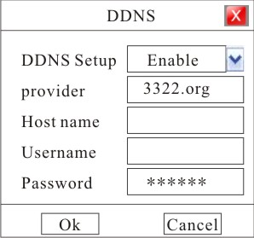
In DDNS interface, choose "dyndns" in provider, input Hostname, username and password,then choose"Enable", "OK" to finish it.

